**BootStrap Classes:**

**Navbar Containers:**

1.container

2.container-sm

3.container-md

4.container-lg

5.container-fluid

6.container-xl

7.container-xxl

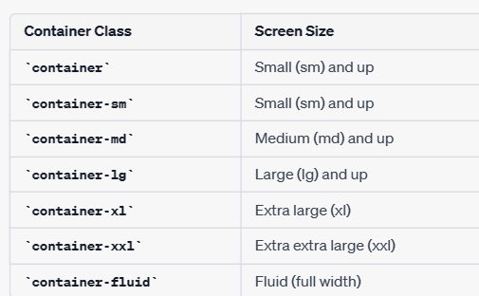

Container:

    <nav class="navbar bg-info">

      <div class="container">

        <a href="" class="navbar-brand">Brand Name</a>

        <span class="navbar-text">Container</span>

        <form action="" class="d-flex" role="search">

          <div class="input-group">

            <input type="search" name="" id="" class="form-control" />

            <button class="btn btn-success">Search</button>

          </div>

        </form>

      </div>

    </nav>

Container-sm:

   <nav class="navbar bg-primary">

      <div class="container-sm">

        <a href="#" class="navbar-brand">Brand</a>

        <span class="navbar-text">Container SM</span>

        <form action="" class="d-flex">

          <input type="search" name="" id="" class="form-control" />

          <button class="btn btn-success">Search</button>

        </form>

      </div>

    </nav>

Container-md:

   <nav class="navbar bg-danger">

      <div class="container-md">

        <a href="#" class="navbar-brand">Brand</a>

        <span class="navbar-text">Container MD</span>

        <form action="" class="d-flex">

          <input type="search" name="" id="" class="form-control" />

          <button class="btn btn-success">Search</button>

        </form>

      </div>

    </nav>

‘

Container-lg:

    <nav class="navbar bg-dark">

      <div class="container-lg">

        <a href="#" class="navbar-brand text-info">Brand</a>

        <span class="navbar-text text-info">Container LG</span>

        <form action="" class="d-flex">

          <input type="search" name="" id="" class="form-control" />

          <button class="btn btn-success">Search</button>

        </form>

      </div>

    </nav>

Container-fluid:

    <nav class="navbar bg-secondary">

      <div class="container-fluid">

        <a href="#" class="navbar-brand">Brand</a>

        <span class="navbar-text">Container-fluid</span>

        <form action="" class="d-flex">

          <input type="search" name="" id="" class="form-control" /><button

            class="btn btn-success"

          >

            Search

          </button>

        </form>

      </div>

    </nav>

